Fun with LEDs – Activities from Smart Lighting
Ken Connor – Education Director of the Smart Lighting Engineering Research Center which includes faculty, staff and students from RPI (the lead school), BU, New Mexico, Howard, Morgan State, Rose-Hulman and Tufts.
- Chocolate Bunny Melting
  - Equipment: two clamp-on lamps, one LED light bulb and one incandescent light bulb. Chocolate objects to melt (e.g. bunnies, ducks, bears or just chocolate bars).
  - Set-Up: A table, plastic or paper plate to contain the melted chocolate, a shelf or some other object to clamp the lamps on, a power strip to plug in the lamps. Table should be visible to all students.
  - Background: this demo is based on one done by CREE, a company that makes the blue LEDs used to produce white light with the appropriate phosphor. There is a YouTube video of their demo at http://www.creeledrevolution.com/blog/2010/03/31/chocolate-bunny-melts-under-incandescent-light-survives-led-light/
  - Takeaways: None, since the students are not to eat the chocolate. It is really good when it is melted, though.
- Light Spectra from Standard Bulbs
  - Equipment: diffraction grating slide to observe the colors produced by each type of bulb (http://www.rainbowsymphonystore.com/difgratslidl.html). Three clamp-on lamps and one each LED, incandescent and CFL bulbs
  - Set-Up: A vertical support of some kind for the lamps. We use the side supports of shelves, coat racks, doors, etc. A power strip to plug in the lamps. Should be visible to all students. This is best done with no other lights on in the room and shades drawn on windows, if possible. If not, then the set-up should not be near windows. It works anywhere, but better with no other sources of light.
  - Background: Sunlight contains all of the colors of the visible spectrum (ROYGBIV). LED bulbs produce light that looks white with a blue LED surrounded by a yellow or lime green phosphor that down converts the blue light to the other colors of the spectrum. Incandescent bulbs produce a great deal of light from the infrared (which is why they are so hot), which cannot be seen, through the rest of the visible spectrum. They are less bright at the blue end, which is why their light looks warmer. CFLs produce light that looks white by combining 5 or so specific colors and not the entire visible spectrum. This is one of the reasons why the light never seems really natural. When one observes the light from a table lamp with a CFL bulb, it can look like the picture below. The lamp with an incandescent bulb will not show distinct images of the lamp in different colors because all colors are produced.
  - Takeaways: The students will keep the diffraction grating slides so they can try this out at home with their parents.
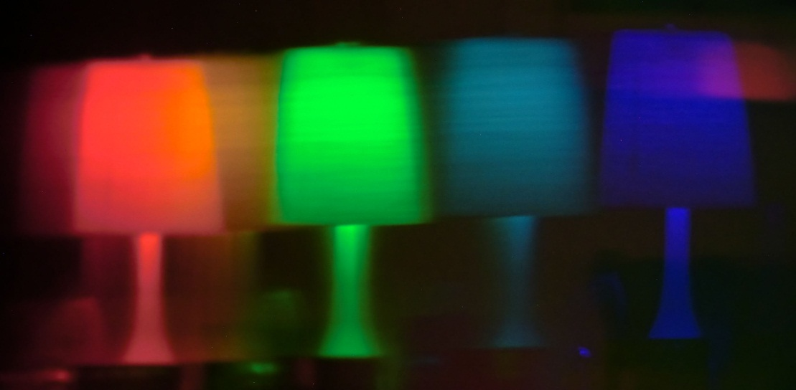
- LED Stickies
  - Equipment: One LED, one 3V coin battery, one very strong (Neodymium-Iron-Boron) magnet.
  - Set-Up: This should be done by each student at their desks or at tables. They will need two pieces of tape, each about 3-4” long. It is probably best if these are prepared ahead of time.
  - Background: This demo/experiment was originally called ‘Throwies’ and there is lot of info online (see below). We changed the name to ‘Stickies’ so students do not throw them everywhere. They will stick to anything magnets will stick to (steel doors, shelves, light fixtures, appliances, etc.). The magnets are very strong, but small, so can be managed by small people. However, they are sufficiently strong that they can attach themselves to objects sufficiently well to be difficult to remove. They can also erase credit card strips and can be attracted to one another with sufficient force to cause some injuries. The biggest problem with two magnets is that they can pinch skin. Used in combination with several magnets the forces can become quite impressive. It is best to keep tape on the magnets.
    - http://www.hobbymods.com/LED%20Throwie%20kits%20with%20CR2032%20batteries%20and%20supplies.htm
    - http://www.lilyleds.com/productdetail.aspx?id=9287&categoryid=113
    - http://www.graffitiresearchlab.com/blog/projects/led-throwies/#video
    - http://www.youtube.com/watch?v=YjTP_T-wR9w
  - Takeaways: The students get to keep their ‘Stickie.’ One of our favorite things to do with the ‘Stickie’ is to find the head of a sheetrock nail or screw in the wall. When an LED is placed close to a flat surface and shines its light parallel to the surface, the light pattern looks like a little angel. Thus, the ‘Stickie’ that is stuck to a sheetrock nail head will make a little angel on the wall.

